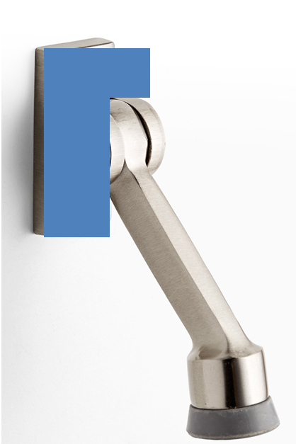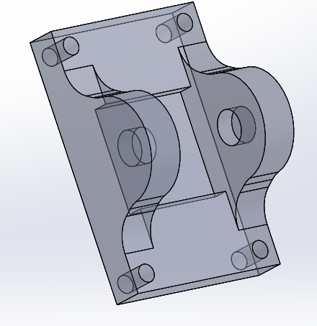

1. Standard Hole Sizes

It is best to use standard drill sizes whenever possible to avoid the added cost of special drill grinding. Standardize the size of holes, fasteners, and other screw threads as much as possible so that the number of drill spindles and drill changes can be minimized.

1. Inaccessible Features

Features should be easily accessible for machining in the required direction. Avoid undercuts, if possible, because they usually involve separate operations of specially ground tools.

1. Sharp Internal Corners

Avoid designs that require sharp internal corners. Sharp inside corners cannot be achieved with traditional milling and require nontraditional machining processes such as electrical discharge machining (EDM).